MINISTRY OF EDUCATION AND SCIENCE OF UKRAINE

NATIONAL TECHNICAL UNIVERSITY

“KHARKOV POLYTECHNICAL INSTITUTE”

LABORATORY WORK № 2

“Learning basic principles of C++”

Created by student of 1.КН.201.8г

Ohol K.V

Teacher

Melnik K.V

KHARKIV 2018

Topic: Learning basic principles of C++  
Goal: Learning basic principles of C++

Tasks:

1. Develop the code for the task from previous lab.

2. Prepare the report of the work

Progress of the lab

1. Develop the code for the task from previous lab..

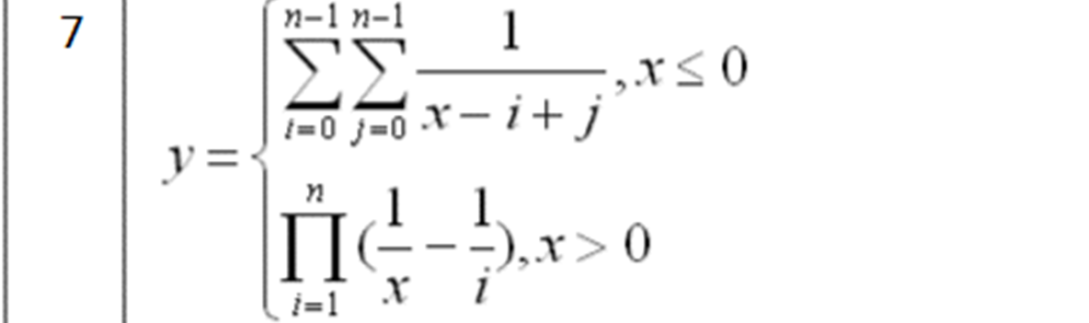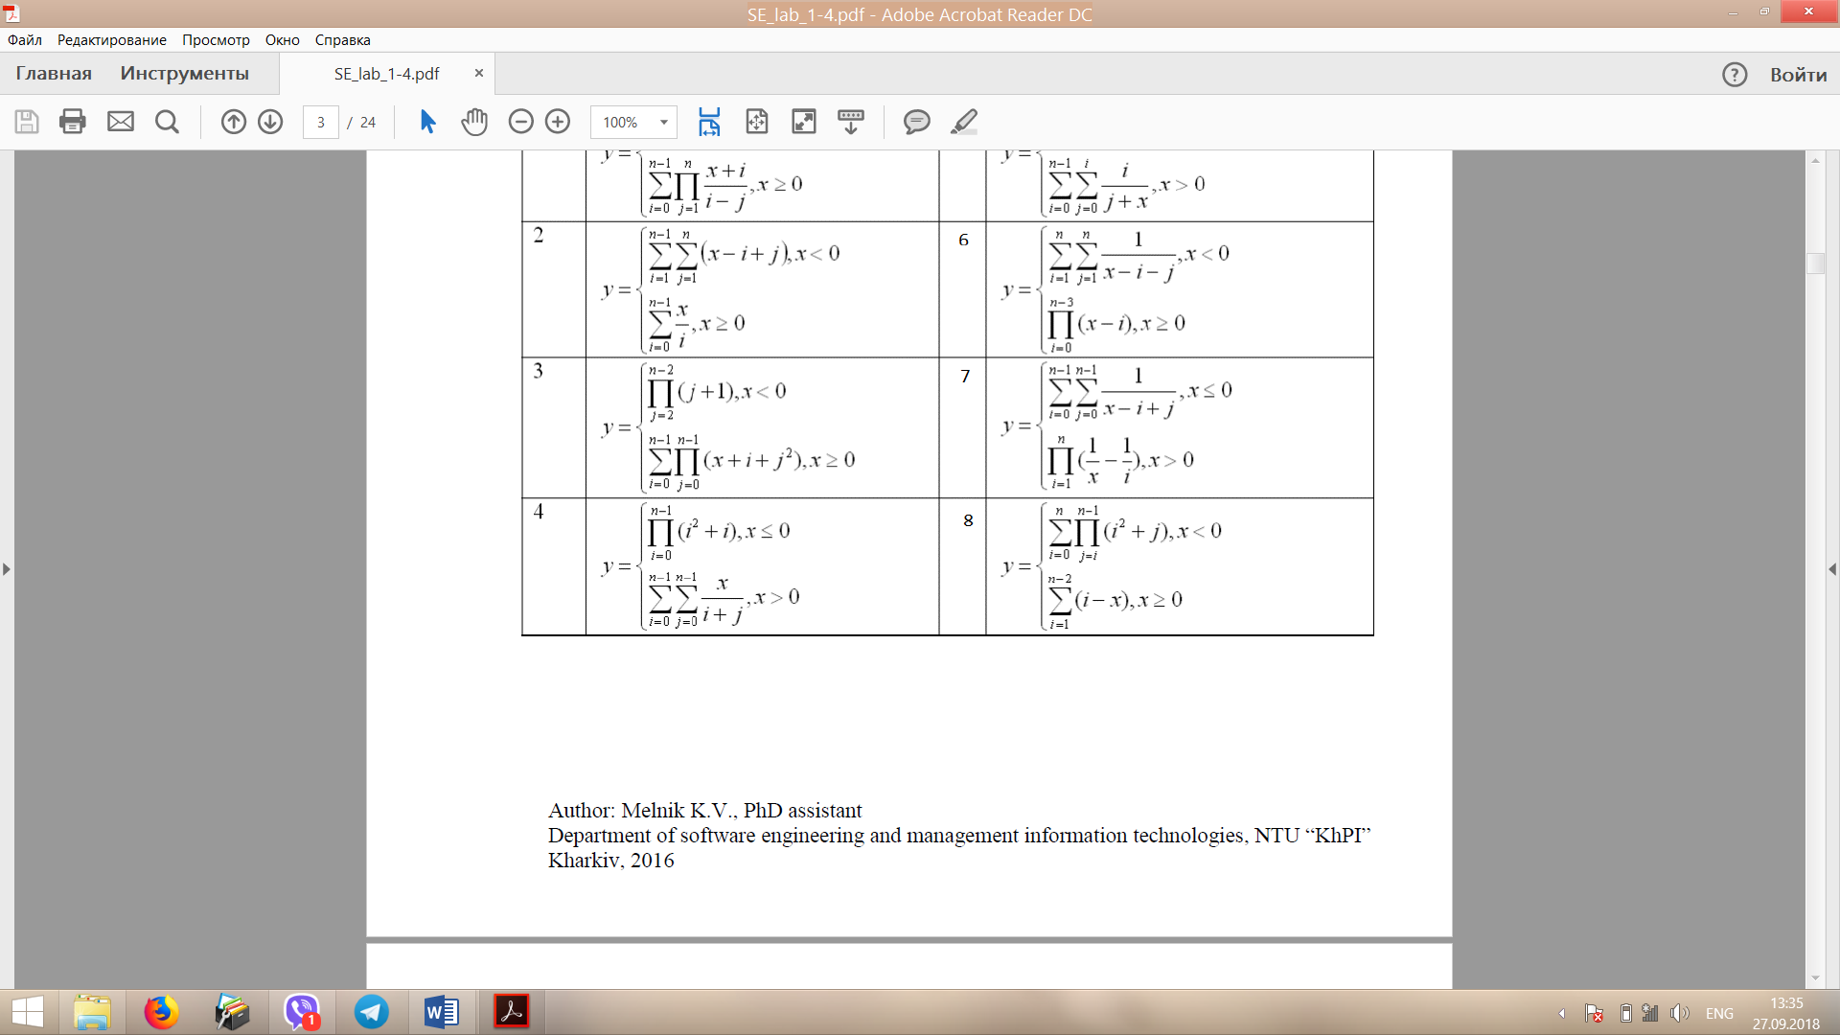

1. 1.1 The Code

#include<iostream>

using namespace std;

//PROGRAMME FOR FIND Y (7 VARIANT)

void main() {

double x,y;

int i, j, n,k;

cout << "Input x ";

while (!(cin >> x) || (cin.peek() != '\n'))

{

cin.clear();

while (cin.get() != '\n');

cout << "Error! You entered non numeric data" << endl<<"Input x ";

}

cout << "Input n" << endl;

while (!(cin >> n) || (cin.peek() != '\n'))

{

cin.clear();

while (cin.get() != '\n');

cout << "Error! You entered non numeric data" << endl << "Input n ";

}

k = n - 1;

if (x > 0)

{

y = 1;

for (i = 1; i <= n; i++)

{

y \*= (1 / x) - (1 / i);

}

}

else

{

y = 0;

for (i = 1; i <= k; i++)

{

for (j = 1; j <=k; j++)

{

try

{

if (x - i == -j|| (x == 0 && i == j))

{

throw 123;

}

}

catch (int t)

{

cout << "Error "<<i<<" : Division by zero" << endl;

}

y += 1 / (x - i + j);

}

}

}

cout <<"The answer : y = "<< y<<endl;

system("pause");

}

1.1.2 Execution result

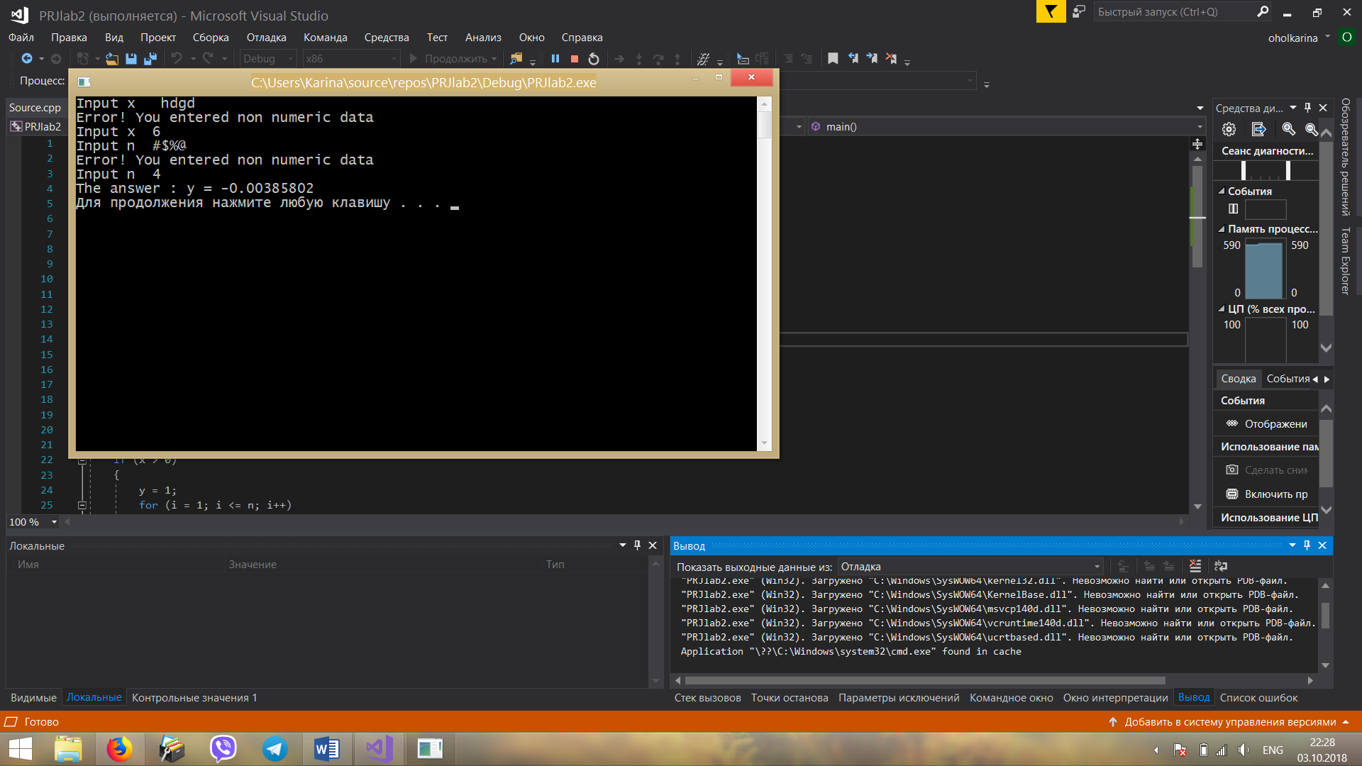

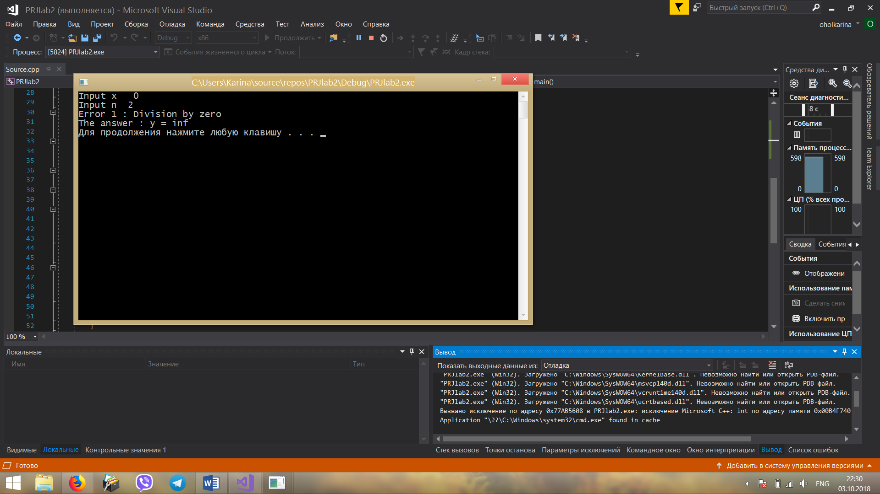

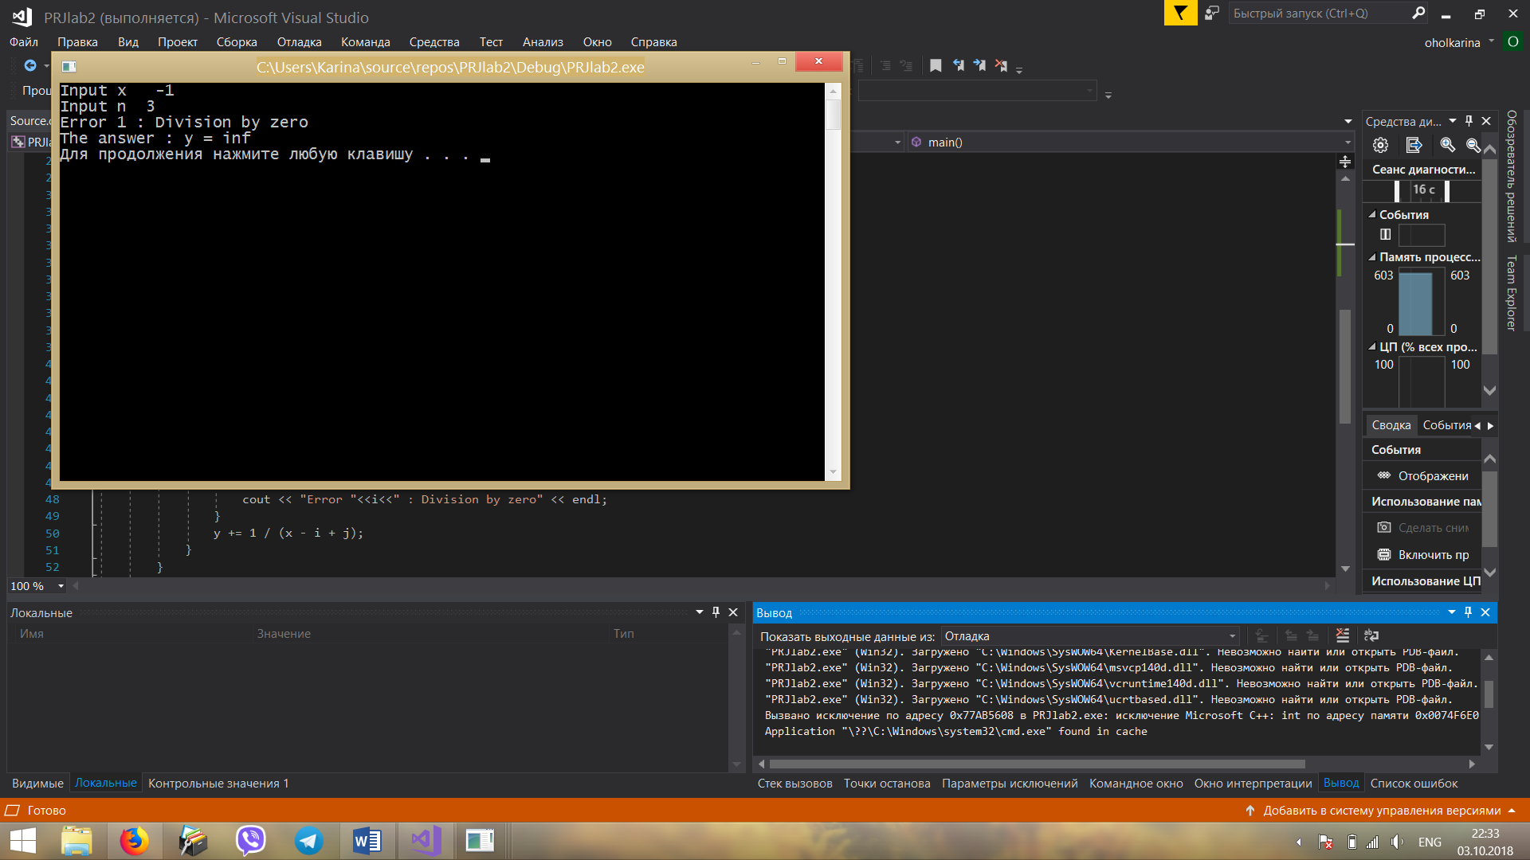

1.2.1Modify the program: program should calculate function y for each value x from range (a,b) with step.

#include<iostream>

using namespace std;

//PROGRAMME FOR FIND Y (7 VARIANT)

void main() {

double y,a,b,step,f;

int i, j, k,n;

cout << "Input n ";

while (!(cin >> n) || (cin.peek() != '\n'))

{

cin.clear();

while (cin.get() != '\n');

cout << "Error! You entered non numeric data" << endl << "Input n ";

}

while (n <= 0) {

cout << "Invalide date : n must be > 0" << endl;

cin >> n;

}

cout << "Input point a " ;

while (!(cin >> a) || (cin.peek() != '\n'))

{

cin.clear();

while (cin.get() != '\n');

cout << "Error! You entered non numeric data" << endl << "Input a ";

}

cout << "Input point b " ;

while (!(cin >> b) || (cin.peek() != '\n'))

{

cin.clear();

while (cin.get() != '\n');

cout << "Error! You entered non numeric data" << endl << "Input b ";

}

while (a >= b)

{

cout << "Error!Value a can not be greater than value b"<<endl<<"Input point b ";

cin >>b;

}

cout << "Input step " ;

while (!(cin >> step) || (cin.peek() != '\n'))

{

cin.clear();

while (cin.get() != '\n');

cout << "Error! You entered non numeric data" << endl << "Input step ";

}

while (step <= 0)

{

cout << "Error! Step can`t be negative" << endl << "Input step ";

cin >> step;

}

k = n - 1;

for (f = a; f <= b; f += step) {

if (f > 0)

{

y = 1;

for (i = 1; i <= n; i++)

{

y \*= (1 / f) - (1 / i);

}

}

else

{

y = 0;

for (i = 1; i <= k; i++)

{

for (j = 1; j <= k; j++)

{

try

{

if (f - i == -j || (f == 0 && i == j))

{

throw 123;

}

}

catch (int t)

{

cout << "Error " << i << " : Division by zero" << endl;

}

y += 1 / (f - i + j);

}

}

}

cout << "The answer : y = " << y << endl;

}

system("pause");

}

1.2.2 Execution result

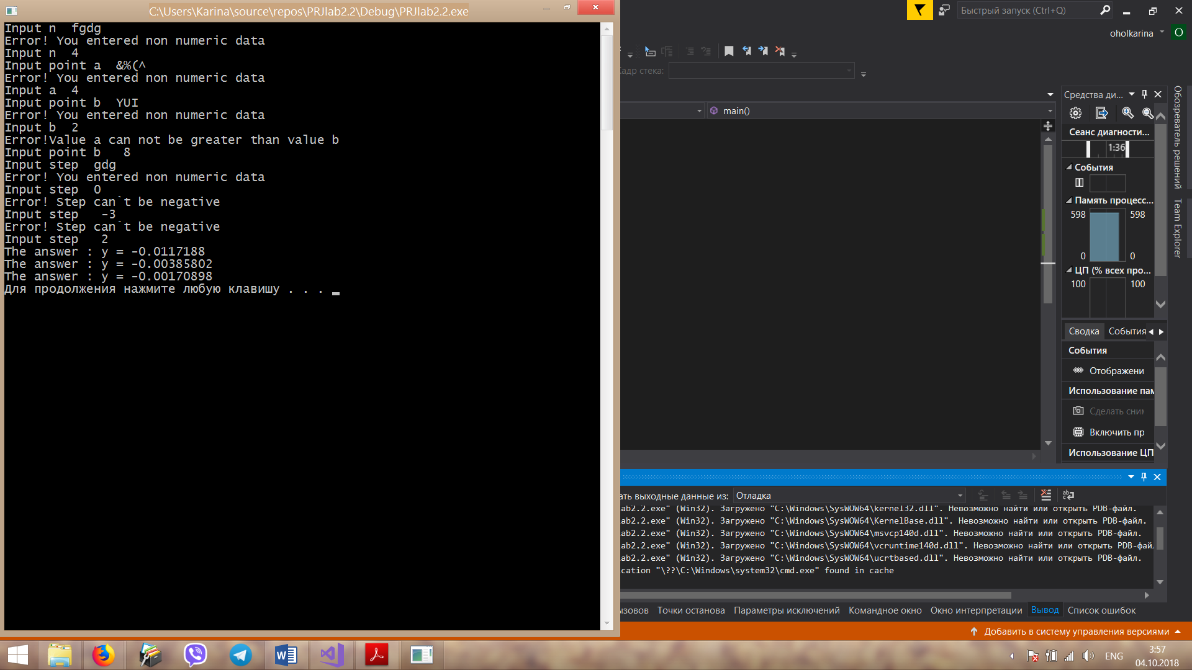

Conclusion: I received practical skills of work with basic principles of C++.I was informed about recommendations on use operators and cycles. I learned how to develop the code for the task using basic C++ operators.